**Operation Analytics and Investigating Metric Spike**

Arcot Navya Sai ([navyasaipatnaik@gmail.com](mailto:navyasaipatnaik@gmail.com)) +918074851394

**Project Description:**  Inthis project we are going to do the complete end-to-end analysis of the operation analytics of a company and also find out the Investigating metric spike. With the help of operation analytics we find the insights about the job data and review of jobs. In investigating metric spike we have found the performance of the company by understanding the user metrics, I have used Advanced SQL queries to answer the case study. Let us discuss in detail.

**Approach:** First I have downloaded the given data sets for the two case studies and understood the data, as the data sets were in the CSV format I had to load them into the database by writing the SQL queries, but the data were very big so I have used the import wizard to load the data into MySQL Workbench. As I have understood the data I started working with the queries using Advance SQL, it was bit complex at the beginning but later I found the importance of earning the data.

**Tech-Stack Used**: I have used

1. MySQL server 8.0
2. MySQL Workbench 8.0.18
3. MySQL shell 8.0

**Insights:**

**Case Study 1 (Job Data):**

1. **Number of jobs reviewed:**

'0.0111' are the number of jobs reviewed per hour per day in the month of November 2020

1. **Throughput:**

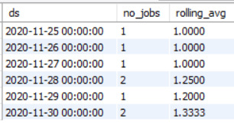

The above table gives the 7 day rolling average to the throughput, I prefer the rolling average compared to the daily metric because when the is large data the rolling average gives the clear insights if the metric is increasing or decreasing using the daily metric we will get many fluctuations with which it is hard to make decisions.

1. **Percentage share of each language:**

Share of each language for each content in the last 30 days is given by the below table

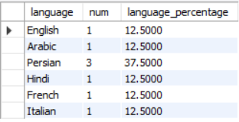

1. **Duplicate rows:**



In the data we do not have any duplicate rows or values.

**Case Study 2 (Investigating metric spike):**

1. **User Engagement:**

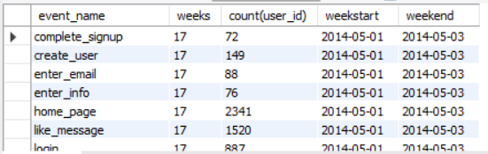

**Output file link:** [**https://drive.google.com/file/d/1__aBmz6Vu_Yx_ghbwxlr2117nyQooORc/view?usp=sharing**](Operation%20Analytics%20and%20Investigating%20Metric%20Spike.docx)User weekly engagement as per the events as given with the number of users weekly engaging in activities. 396 rows are given as the output.

1. **User Growth:**

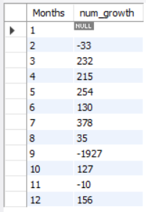

User growth (change) per month is given in the above table. Negative sign indicate the decrease in the number of users

1. **Weekly Retention:**

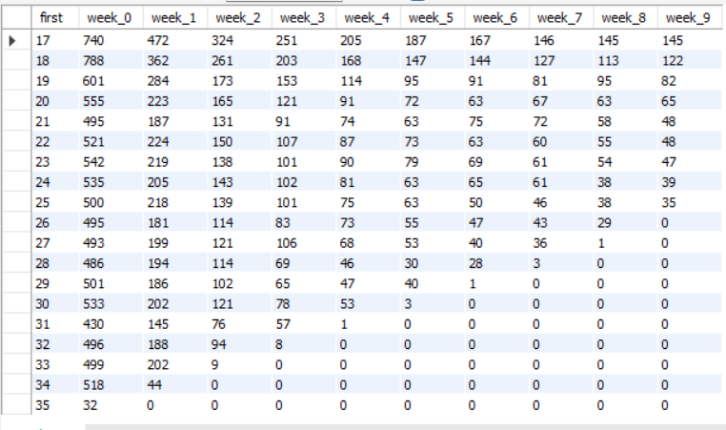

Weekly retention for consecutive weeks starting from the first week all the number of users retained in the consecutive weeks is given.

1. **Weekly Engagement:**

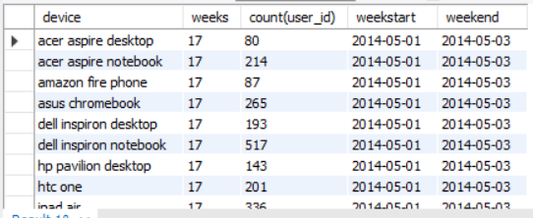

**Output file link:** [https://drive.google.com/file/d/1hA9Jf9XPpL-w5zU0CBxio5FBWcP0sJiK/view?usp=sharing](Operation%20Analytics%20and%20Investigating%20Metric%20Spike.docx)

Weekly engagement of users as per the device they are using is given in the table above.

1. **Email Engagement:**

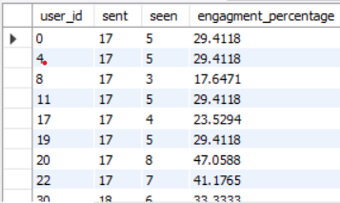

**Output file link:** [**https://drive.google.com/file/d/1ey7q2P24qvjO9UI8EM56YHCCTh4jx7EH/view?usp=sharing**](Operation%20Analytics%20and%20Investigating%20Metric%20Spike.docx)

Email user engagement metric is given by user_id, I have taken the data of emails sent to users and the emails opened by the user, to understand more about the user email engagement we have taken the percentage of opened emails by user.

**Results:** This Project was the great Practise for the real life Case studies and the Business Intelligence point of view. It was the wonderful experience. Initially I faced issues in uploading the huge data sets to the database but gradually learnt and applied all the concepts newly learnt in the Advanced SQL topics.

**Drive Link:** [**https://drive.google.com/file/d/15feaWbTQecDNLcKqr-GDkLUKg4Ir6-fa/view?usp=sharing**](Operation%20Analytics%20and%20Investigating%20Metric%20Spike.docx)

**Thank You.**